Rain Alarm System
Description:
An electronic alarm system that detects rain using a rain sensor or metal plate electrodes and alerts via buzzer/LED.
Block Diagram:
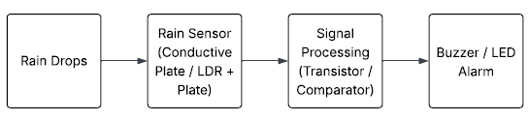
Pinout / Circuit Connection:
- Rain Sensor Module/Metal Plate → Digital Input D2 on Arduino
- Buzzer → Digital Pin 8
Components Required:
- Arduino UNO
- Rain Sensor Module or DIY rain detector plate
- Buzzer
- 220Ω Resistor
- Jumper wires
- Breadboard
Working Principle:
When raindrops fall on the sensor plate, resistance changes, Arduino detects it and triggers buzzer/LED alarm.
Operation (Step-by-Step):
- Power ON the Arduino.
- Rain sensor detects rain drops.
- Arduino reads input from sensor.
- If rain detected → buzzer sounds.
Arduino Code:
#define RAIN_PIN 2
#define BUZZER_PIN 8

void setup() {
pinMode(RAIN_PIN, INPUT);
pinMode(BUZZER_PIN, OUTPUT);
Serial.begin(9600);
}

void loop() {
if (digitalRead(RAIN_PIN) == LOW) {
digitalWrite(BUZZER_PIN, HIGH);
Serial.println("Rain Detected");
} else {
digitalWrite(BUZZER_PIN, LOW);
Serial.println("No Rain");
}
delay(500);
}

Conclusion: (Predefined/self-written)
The Rain Alarm System provides a simple and effective way to detect rainfall and trigger alerts for applications like agriculture and household safety.
For Your References:
[1] Arduino Project Hub, 'Rain Sensor Module Tutorial,' https://projecthub.arduino.cc

